Week 4.1

* Lab activity… like a practice test…
  + Learn copy/paste
  + Learn “snipping tool”
* “Explain variation”
  + Specific - “knowing someone’s sex helps us make a better guess about height”
  + More generally - “knowing someone’s value on explanatory variable help you make a better guess about value on outcome variable”
  + What does “explained” really mean? Measured (e.g., the explanatory variable is in our data)
  + 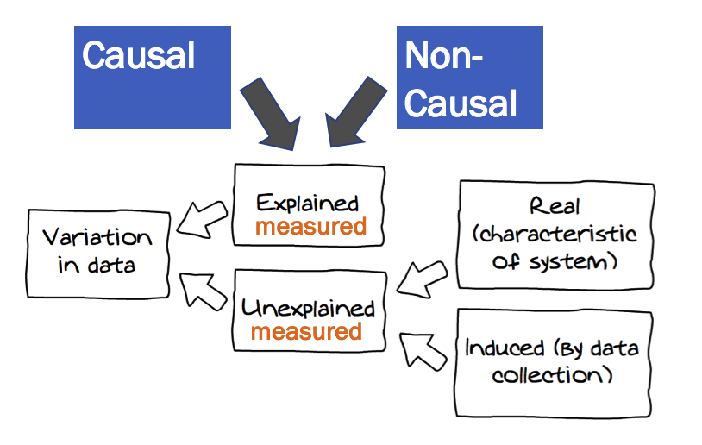
* Galton
  + head(Galton)
  + Make a “parent” average height of mother and father
  + Does “explain variation” definition work even in the case of a quantitative explanatory variable?
  + “Knowing someone’s value on explanatory helps us make a better guess about outcome”
* How come in the Galton example, father’s height is part of explained variation but in profiles, father’s height is part of unexplained variation?
* USStates
  + FiveVegetables
  + http://bit.ly/cw4-2
  + What might explain variation in the proportion of people in a state that eat their 5 fruits and veggies?
    - Come up with a theory of the DGP
    - Write a word equation for your DGP
    - Explore that variation with some sort of visualization
    - Have you “explained (some of the) variation”? Remember our little definition -- “Knowing someone’s value on explanatory helps us make a better guess about outcome”